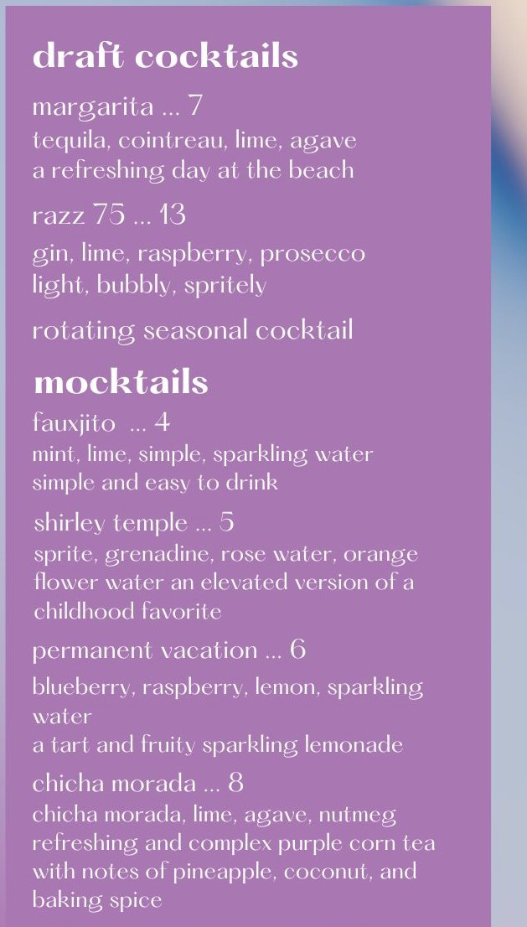

508 austin ave. u,aco, tx
bar hours: sun - (hurs 5 p - '11p fri - sat 3 p - 12 a

happy hour
J- 7 pm C\'Cr cla

craft cocktails
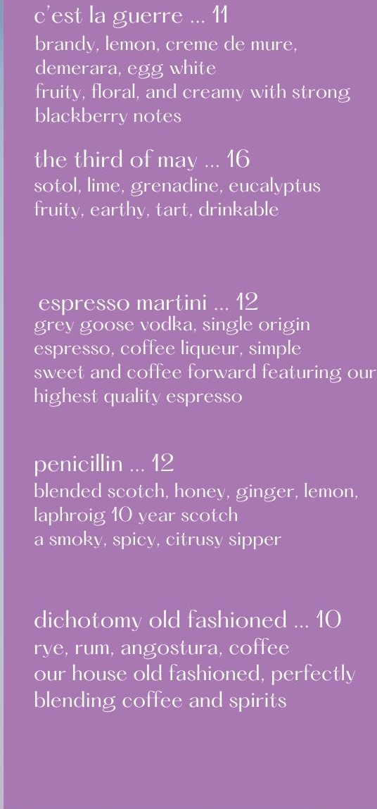
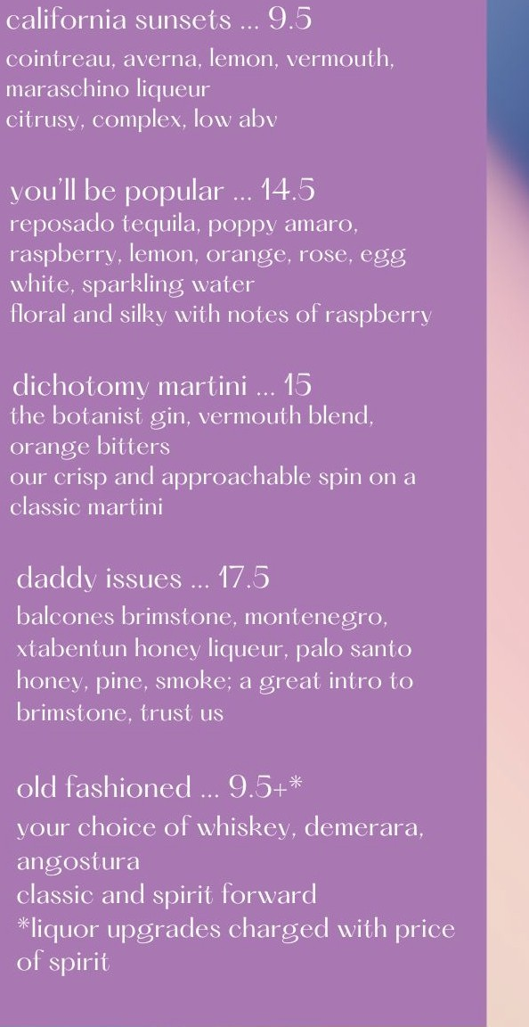
lighter cocktails are near the lop, spirit forward cocktails arc near the bottom.
